**Keyes 3.5英寸TFT LCD Shield 扩展板**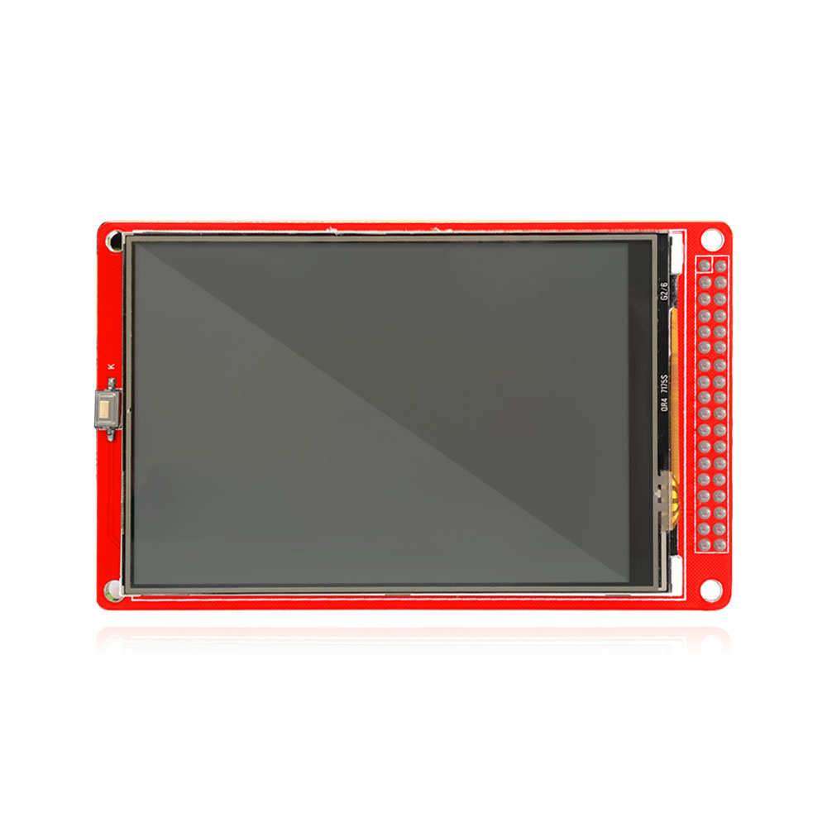

**1.说明**

LCD 面板尺寸：3.5英寸•

视角方向:9:00 O’Clock

LCD 驱动芯片：ILI9481

逻辑电平:2.8V-3.3V •

数据接口:16总线接口

扩展板模式:16位总线模式

供电电压:DC 5V

触感控制板

白色背光

1. **技术参数**

**参数**   **规格**  **单位**

**色彩**  262K

**有效面积**  48.96*73.44  mm2

**玻璃面积**   52.96 ×81.44  mm2

**分辨率**   W/H 320×480 Dot

**模组功耗**   90-120  mW

**LCD 类型**  TFT   -

1. **连接图**

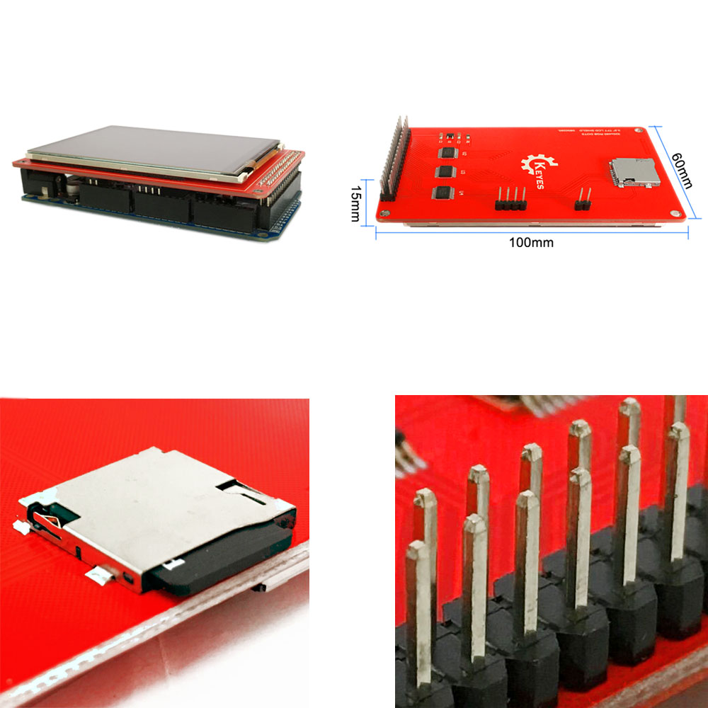

1. **测试程序**

// UTFT_Demo_480x320 (C)2014 Henning Karlsen

// web: http://www.henningkarlsen.com/electronics

//

// This program is a demo of how to use most of the functions

// of the library with a supported display modules.

//

// This demo was made for modules with a screen resolution

// of 480x320 pixels.

//

// This program requires the UTFT library.

//

#include <UTFT.h>

// Declare which fonts we will be using

extern uint8_t SmallFont[];

// Set the pins to the correct ones for your development shield

// ------------------------------------------------------------

// Arduino Uno / 2009:

// -------------------

// Standard Arduino Uno/2009 shield : <display model>,A5,A4,A3,A2

// DisplayModule Arduino Uno TFT shield : <display model>,A5,A4,A3,A2

//

// Arduino Mega:

// -------------------

// Standard Arduino Mega/Due shield : <display model>,38,39,40,41

// CTE TFT LCD/SD Shield for Arduino Mega : <display model>,38,39,40,41

//

// Remember to change the model parameter to suit your display module!

UTFT myGLCD(ILI9481,38,39,40,41);

void setup()

{

randomSeed(analogRead(0));

// Setup the LCD

myGLCD.InitLCD();

myGLCD.InitLCD();

myGLCD.setFont(SmallFont);

}

void loop()

{

int buf[478];

int x, x2;

int y, y2;

int r;

// Clear the screen and draw the frame

myGLCD.clrScr();

myGLCD.setColor(255, 0, 0);

myGLCD.fillRect(0, 0, 479, 13);

myGLCD.setColor(64, 64, 64);

myGLCD.fillRect(0, 306, 479, 319);

myGLCD.setColor(255, 255, 255);

myGLCD.setBackColor(255, 0, 0);

myGLCD.print("* Universal Color TFT Display Library *", CENTER, 1);

myGLCD.setBackColor(64, 64, 64);

myGLCD.setColor(255,255,0);

myGLCD.print("<http://electronics.henningkarlsen.com>", CENTER, 307);

myGLCD.setColor(0, 0, 255);

myGLCD.drawRect(0, 14, 479, 305);

// Draw crosshairs

myGLCD.setColor(0, 0, 255);

myGLCD.setBackColor(0, 0, 0);

myGLCD.drawLine(239, 15, 239, 304);

myGLCD.drawLine(1, 159, 478, 159);

for (int i=9; i<470; i+=10)

myGLCD.drawLine(i, 157, i, 161);

for (int i=19; i<220; i+=10)

myGLCD.drawLine(237, i, 241, i);

// Draw sin-, cos- and tan-lines

myGLCD.setColor(0,255,255);

myGLCD.print("Sin", 5, 15);

for (int i=1; i<478; i++)

{

myGLCD.drawPixel(i,159+(sin(((i*1.13)*3.14)/180)*95));

}

myGLCD.setColor(255,0,0);

myGLCD.print("Cos", 5, 27);

for (int i=1; i<478; i++)

{

myGLCD.drawPixel(i,159+(cos(((i*1.13)*3.14)/180)*95));

}

myGLCD.setColor(255,255,0);

myGLCD.print("Tan", 5, 39);

for (int i=1; i<478; i++)

{

myGLCD.drawPixel(i,159+(tan(((i*1.13)*3.14)/180)));

}

delay(2000);

myGLCD.setColor(0,0,0);

myGLCD.fillRect(1,15,478,304);

myGLCD.setColor(0, 0, 255);

myGLCD.setBackColor(0, 0, 0);

myGLCD.drawLine(239, 15, 239, 304);

myGLCD.drawLine(1, 159, 478, 159);

// Draw a moving sinewave

x=1;

for (int i=1; i<(478*15); i++)

{

x++;

if (x==479)

x=1;

if (i>479)

{

if ((x==239)||(buf[x-1]==159))

myGLCD.setColor(0,0,255);

else

myGLCD.setColor(0,0,0);

myGLCD.drawPixel(x,buf[x-1]);

}

myGLCD.setColor(0,255,255);

y=159+(sin(((i*0.7)*3.14)/180)*(90-(i / 100)));

myGLCD.drawPixel(x,y);

buf[x-1]=y;

}

delay(2000);

myGLCD.setColor(0,0,0);

myGLCD.fillRect(1,15,478,304);

// Draw some filled rectangles

for (int i=1; i<6; i++)

{

switch (i)

{

case 1:

myGLCD.setColor(255,0,255);

break;

case 2:

myGLCD.setColor(255,0,0);

break;

case 3:

myGLCD.setColor(0,255,0);

break;

case 4:

myGLCD.setColor(0,0,255);

break;

case 5:

myGLCD.setColor(255,255,0);

break;

}

myGLCD.fillRect(150+(i*20), 70+(i*20), 210+(i*20), 130+(i*20));

}

delay(2000);

myGLCD.setColor(0,0,0);

myGLCD.fillRect(1,15,478,304);

// Draw some filled, rounded rectangles

for (int i=1; i<6; i++)

{

switch (i)

{

case 1:

myGLCD.setColor(255,0,255);

break;

case 2:

myGLCD.setColor(255,0,0);

break;

case 3:

myGLCD.setColor(0,255,0);

break;

case 4:

myGLCD.setColor(0,0,255);

break;

case 5:

myGLCD.setColor(255,255,0);

break;

}

myGLCD.fillRoundRect(270-(i*20), 70+(i*20), 330-(i*20), 130+(i*20));

}

delay(2000);

myGLCD.setColor(0,0,0);

myGLCD.fillRect(1,15,478,304);

// Draw some filled circles

for (int i=1; i<6; i++)

{

switch (i)

{

case 1:

myGLCD.setColor(255,0,255);

break;

case 2:

myGLCD.setColor(255,0,0);

break;

case 3:

myGLCD.setColor(0,255,0);

break;

case 4:

myGLCD.setColor(0,0,255);

break;

case 5:

myGLCD.setColor(255,255,0);

break;

}

myGLCD.fillCircle(180+(i*20),100+(i*20), 30);

}

delay(2000);

myGLCD.setColor(0,0,0);

myGLCD.fillRect(1,15,478,304);

// Draw some lines in a pattern

myGLCD.setColor (255,0,0);

for (int i=15; i<304; i+=5)

{

myGLCD.drawLine(1, i, (i*1.6)-10, 304);

}

myGLCD.setColor (255,0,0);

for (int i=304; i>15; i-=5)

{

myGLCD.drawLine(478, i, (i*1.6)-11, 15);

}

myGLCD.setColor (0,255,255);

for (int i=304; i>15; i-=5)

{

myGLCD.drawLine(1, i, 491-(i*1.6), 15);

}

myGLCD.setColor (0,255,255);

for (int i=15; i<304; i+=5)

{

myGLCD.drawLine(478, i, 490-(i*1.6), 304);

}

delay(2000);

myGLCD.setColor(0,0,0);

myGLCD.fillRect(1,15,478,304);

// Draw some random circles

for (int i=0; i<100; i++)

{

myGLCD.setColor(random(255), random(255), random(255));

x=32+random(416);

y=45+random(226);

r=random(30);

myGLCD.drawCircle(x, y, r);

}

delay(2000);

myGLCD.setColor(0,0,0);

myGLCD.fillRect(1,15,478,304);

// Draw some random rectangles

for (int i=0; i<100; i++)

{

myGLCD.setColor(random(255), random(255), random(255));

x=2+random(476);

y=16+random(289);

x2=2+random(476);

y2=16+random(289);

myGLCD.drawRect(x, y, x2, y2);

}

delay(2000);

myGLCD.setColor(0,0,0);

myGLCD.fillRect(1,15,478,304);

// Draw some random rounded rectangles

for (int i=0; i<100; i++)

{

myGLCD.setColor(random(255), random(255), random(255));

x=2+random(476);

y=16+random(289);

x2=2+random(476);

y2=16+random(289);

myGLCD.drawRoundRect(x, y, x2, y2);

}

delay(2000);

myGLCD.setColor(0,0,0);

myGLCD.fillRect(1,15,478,304);

for (int i=0; i<100; i++)

{

myGLCD.setColor(random(255), random(255), random(255));

x=2+random(476);

y=16+random(289);

x2=2+random(476);

y2=16+random(289);

myGLCD.drawLine(x, y, x2, y2);

}

delay(2000);

myGLCD.setColor(0,0,0);

myGLCD.fillRect(1,15,478,304);

for (int i=0; i<10000; i++)

{

myGLCD.setColor(random(255), random(255), random(255));

myGLCD.drawPixel(2+random(476), 16+random(289));

}

delay(2000);

myGLCD.fillScr(0, 0, 255);

myGLCD.setColor(255, 0, 0);

myGLCD.fillRoundRect(160, 70, 319, 169);

myGLCD.setColor(255, 255, 255);

myGLCD.setBackColor(255, 0, 0);

myGLCD.print("That's it!", CENTER, 93);

myGLCD.print("Restarting in a", CENTER, 119);

myGLCD.print("few seconds...", CENTER, 132);

myGLCD.setColor(0, 255, 0);

myGLCD.setBackColor(0, 0, 255);

myGLCD.print("Runtime: (msecs)", CENTER, 290);

myGLCD.printNumI(millis(), CENTER, 305);

delay (10000);

}

1. **测试结果**

